JOE STREET COFFEE
For slow mornings, busy afternoons, and little breaks in between.

HOT COFFEE
Drink | Description | Price
Brewed Coffee | Freshly brewed and straight to the point. | ₱59
Americano | Bold coffee with hot water. Clean, simple, and no extras. | ₱79
Café Latte | Smooth coffee with creamy milk and light foam. | ₱89
Salted Caramel Latte | Creamy coffee with caramel and a light salty finish. | ₱99

ICED COFFEE
Drink | Description | Price
Iced Americano | Cold, bold, and refreshing. Strong coffee, no extras. | ₱89
Greek Frappe | Frothy iced coffee, light and refreshing with a smooth finish. | ₱89
French Vanilla Latte | Creamy coffee with French vanilla, soft foam, and just the right sweetness. | ₱99
Spanish Latte | Sweet condensed milk, creamy milk, and coffee over ice. | ₱105
Dalgona Coffee | Whipped coffee over milk. Creamy, fun, and made to stand out. | ₱109
Caramel Macchiato | Sweet condensed milk, creamy milk, coffee, whipped foam, and caramel drizzle. A little extra, in the best way. | ₱119

MAKE IT YOURS +₱20
Add Hazelnut or Salted Caramel to your latte.
A place you can come back to.

JOE STREET COFFEE BUILD GUIDE

STANDARD COFFEE BASE
- Use 45ml espresso for most coffee drinks.
- For Iced Americano, use 45ml espresso, or 75ml strong coffee base if not using espresso.
- Strong coffee base is best served chilled and used within the same day for best taste.

ICED COFFEE RULE FOR MIXED ICE
- Fill cup only 80 to 85% with ice, not overly packed.
- Use more solid ice maker ice first, then crushed ice only to fill gaps.
- Use less water or milk and a stronger coffee base.
- Make iced drinks only when ordered.
- Serve within 3 to 5 minutes.

ICED COFFEE BUILDS

Iced Americano — ₱89
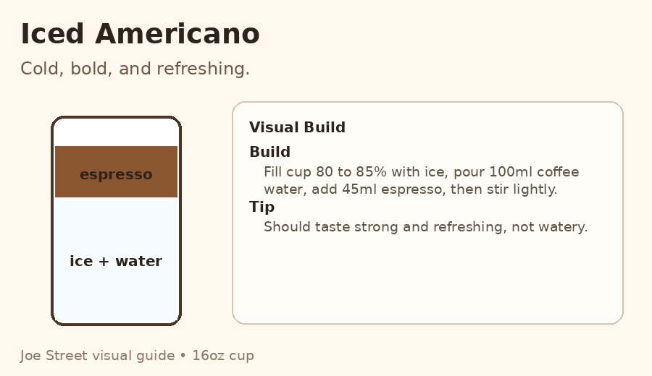 | Ingredients  • 80 to 85% cup ice  • 100ml coffee water  • 45ml espresso  Build  1. Fill cup 80 to 85% with ice.  2. Pour 100ml coffee water.  3. Add 45ml espresso.  4. Stir lightly.  5. Serve immediately.  Staff Note  This should taste cold, bold, and refreshing, not watery.

Greek Frappe — ₱89
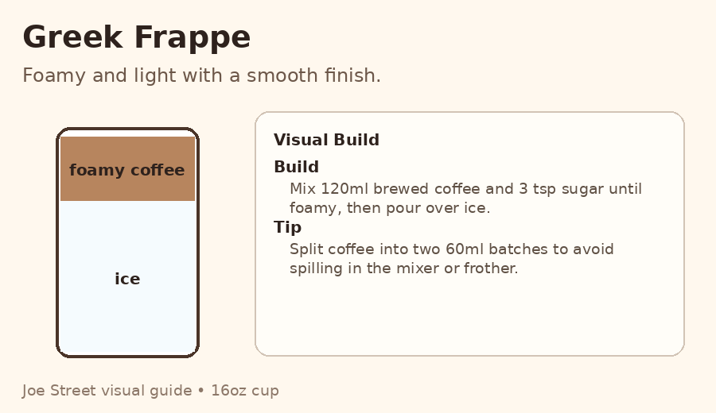 | Ingredients  • 120ml brewed coffee  • 3 tsp sugar  • 80 to 85% cup ice  Build  1. In the mixer, combine brewed coffee and sugar.  2. Mix until foamy.  3. Fill cup 80 to 85% with ice.  4. Pour mixture into the cup.  5. Serve immediately.  Staff Note  To avoid spilling in the mixer or frother, split the coffee into two batches of 60ml.

French Vanilla Latte — ₱99
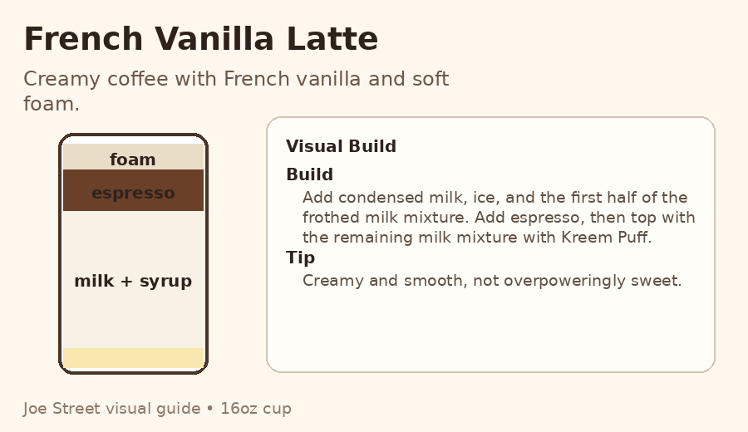 | Ingredients  • 10ml condensed milk  • 80 to 85% cup ice  • 100ml milk  • 20ml French vanilla syrup  • 1 tbsp sugar  • 45ml espresso  • 1 tbsp Kreem Puff  Build  1. Add condensed milk at the bottom of the cup.  2. Froth milk with sugar and French vanilla syrup.  3. Fill cup 80 to 85% with ice.  4. Pour half of the milk mixture into the cup.  5. Add Kreem Puff to the remaining milk mixture and froth again.  6. Slowly add 45ml espresso.  7. Top with remaining milk foam mixture.  8. Serve immediately.  Staff Note  This should taste creamy, smooth, and lightly sweet, not overpowering.

Flavored Latte Add-on — +₱20
Ingredients
• Available flavors: Hazelnut, Salted Caramel
• Add 20ml syrup to the milk before frothing
Build
1. Use 20ml syrup for balanced sweetness.
2. Use 15ml only for customers who prefer it milder.
Staff Note
Apply this add-on to the latte base only.

Spanish Latte — ₱105
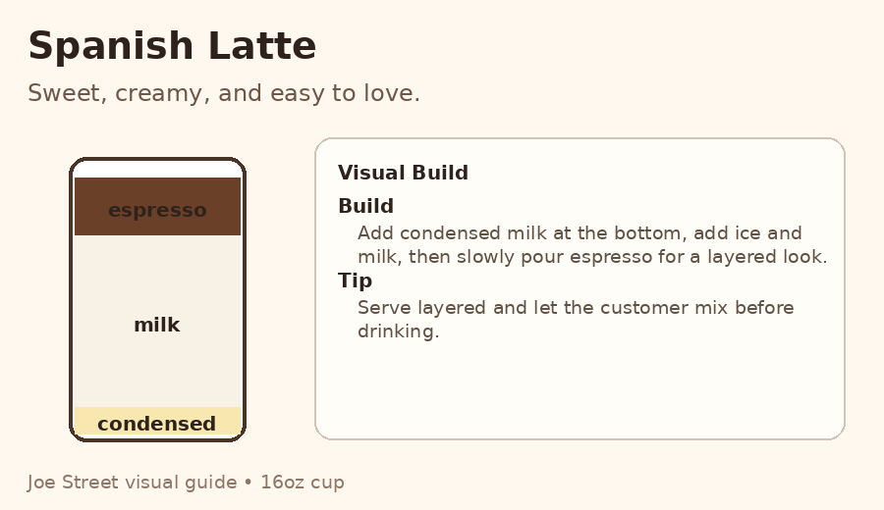 | Ingredients  • 20ml condensed milk  • 80 to 85% cup ice  • 100ml milk  • 45ml espresso  Build  1. Add condensed milk at the bottom of the cup.  2. Fill cup 80 to 85% with ice.  3. Pour 100ml milk.  4. Slowly add 45ml espresso.  5. Serve layered.  6. Serve immediately.  Staff Note  Sweet, creamy, and easy to love. Let the customer mix before drinking.

Dalgona Coffee — ₱109
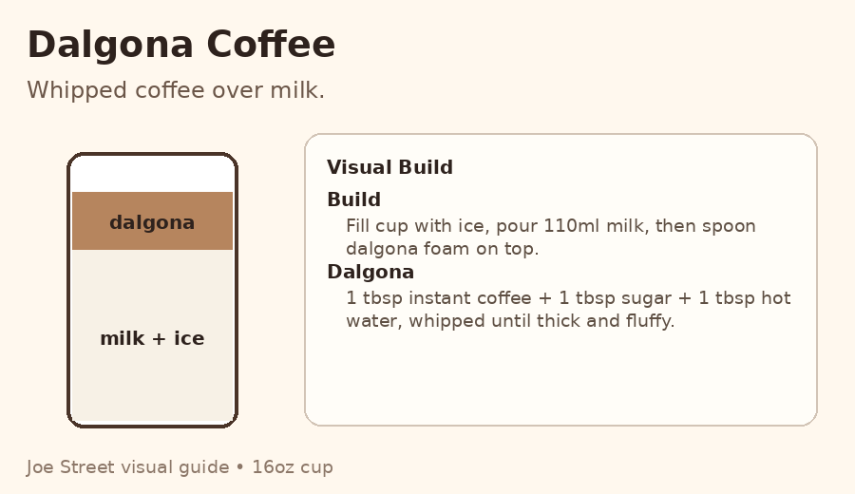 | Ingredients  • 80 to 85% cup ice  • 110ml milk  • Dalgona foam  • Standard dalgona foam: 1 tbsp instant coffee + 1 tbsp sugar + 2 tbsp water  Build  1. Fill cup 80 to 85% with ice.  2. Pour 110ml milk.  3. Spoon dalgona foam on top.  4. Serve immediately without mixing first.  Staff Note: Foam should be thick but still smooth and creamy.

Caramel Macchiato — ₱119 (Joe Street Version)
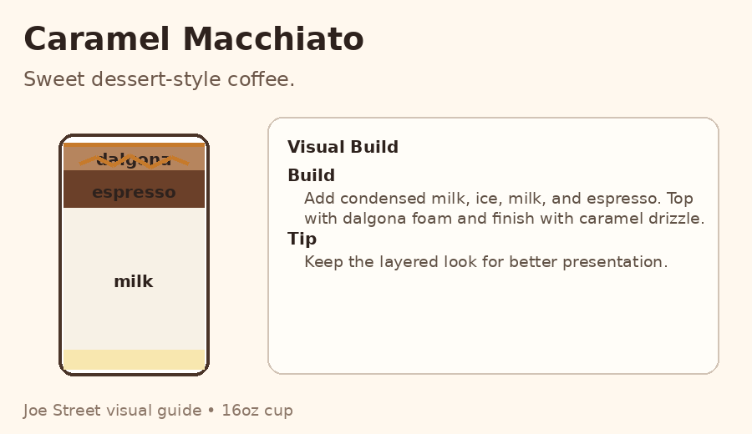 | Ingredients  • 15ml condensed milk  • 80 to 85% cup ice  • 100ml milk  • 45ml espresso  • Dalgona foam  • Caramel drizzle  Build  1. Add condensed milk at the bottom of the cup.  2. Fill cup 80 to 85% with ice.  3. Pour 100ml milk.  4. Slowly add espresso.  5. Add dalgona foam on top.  6. Finish with caramel drizzle.  7. Serve immediately without mixing first.  Staff Note  This is a sweet dessert-style coffee. Keep the layered look for better presentation.

HOT COFFEE RULES
- Serve fresh and warm.
- Do not boil the milk.
- Heat milk only until lightly steaming.
- Foam should look smooth, not bubbly.

HOT COFFEE BUILDS

Brewed Coffee — ₱59
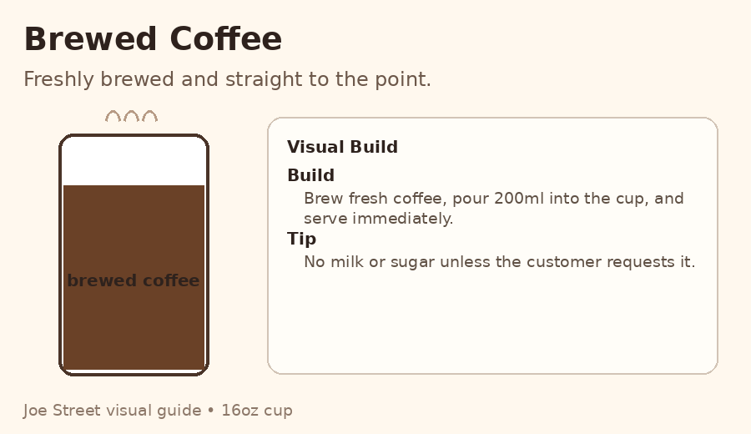 | Ingredients  • 200ml hot brewed coffee  Build  1. Brew coffee fresh.  2. Pour into cup.  3. Serve immediately.  Staff Note  No milk or sugar unless requested.

Hot Americano — ₱79
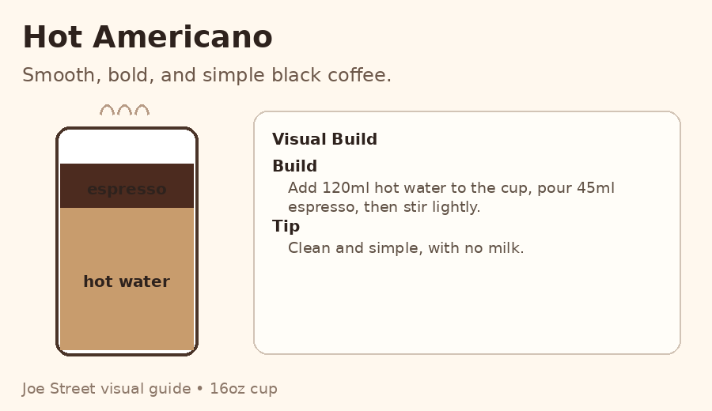 | Ingredients  • 120ml hot water  • 45ml espresso  Build  1. Add hot water to the cup.  2. Add espresso.  3. Stir lightly.  4. Serve immediately.  Staff Note  Smooth, bold, and simple black coffee.

Café Latte — ₱89
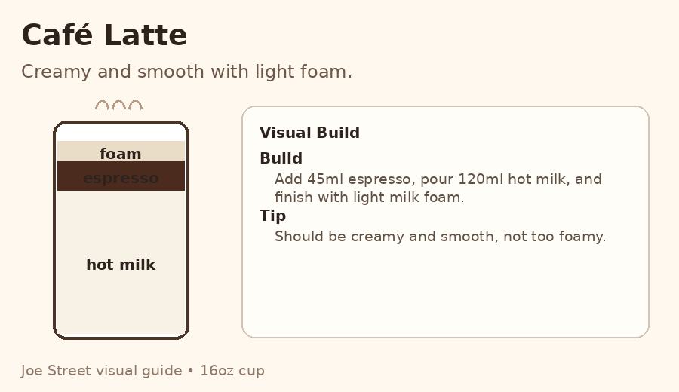 | Ingredients  • 45ml espresso  • 120ml hot milk  • Light milk foam  Build  1. Add espresso into the cup.  2. Heat and froth milk lightly.  3. Pour hot milk into coffee.  4. Add light foam on top.  5. Serve immediately.  Staff Note  Latte should be creamy and smooth, not too foamy.

Salted Caramel Latte — ₱99
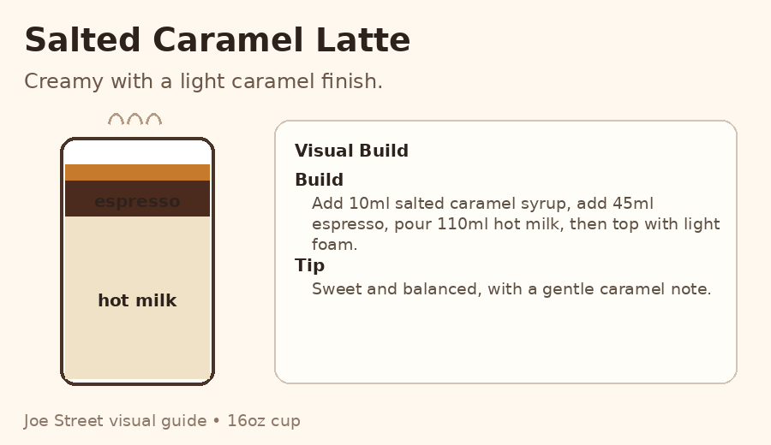 | Ingredients  • 45ml espresso  • 110ml hot milk  • 10ml salted caramel syrup  Build  1. Add salted caramel syrup into the cup.  2. Add espresso.  3. Stir lightly.  4. Pour hot milk.  5. Add light foam on top.  6. Serve immediately.  Staff Note  Sweet, creamy, and balanced with a light caramel finish.

